Abigail & Danielle
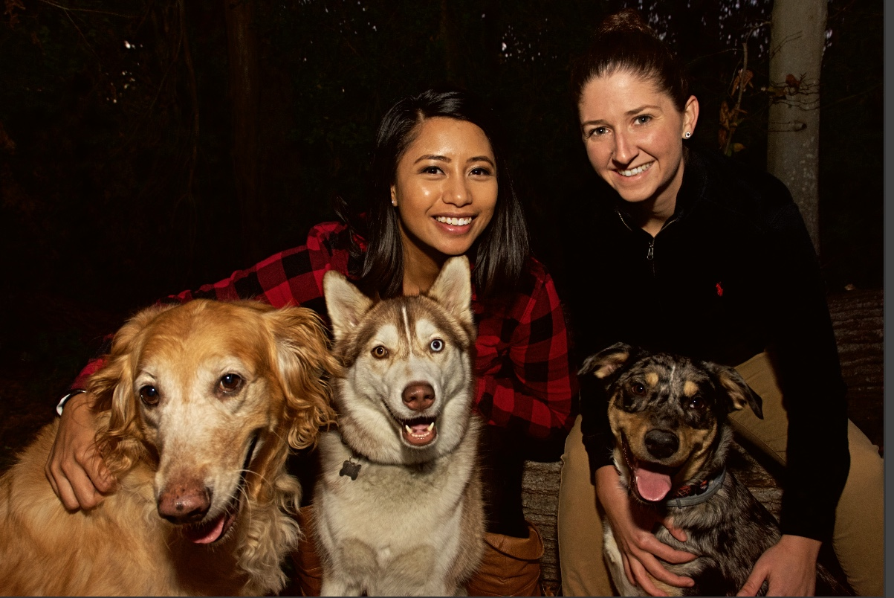

ABOUT US
Sharing the same passion for helping others brought us together. We both work full-time in the same healthcare facility, Abby as a registered nurse and Danielle as the admissions coordinator. We met three years ago at work and have been inseparable ever since. We are the definition of “opposites attract”: Abby is shy and very ambitious, while Danielle is very outgoing and has a great sense of humor. We balance each other out. We enjoy going to the beach, Sunday dinners with our families, and playing with our three fur babies. We both really enjoy being outdoors. Danielle is an avid fisher and ATV rider. Abby enjoys gardening, throwing the football around, and soaking up the sun by the pool. No matter what we are doing, we support each other through it all. Our love is strong, and we look forward to the day when we can share it with our child.

OUR HOME
We live on a 1.5-acre lot in a three-bedroom, two-bath rambler-style home in a rural area of Maryland. We have an open floor plan in our home, which means a lot of running room for a little one. In our backyard, we have a chicken coop with four chickens, so we have fresh eggs just about every day. We have access to many recreational parks and are just minutes away from a beautiful river. Danielle’s family’s farm is about ten minutes away, and Abby’s family is only thirty minutes from us. Our community is very diverse, which allows for opportunities to learn about different cultures.

OUR EXTENDED FAMILY
Our families are our biggest supporters and the closest people to us. They are ecstatic we have chosen to go through the adoption process to grow our family. Danielle has three sisters and one brother, and Abby has one sister. Danielle has four beautiful nieces whom we absolutely adore.
Danielle’s family owns one of the largest farms in our area, and this is where she grew up and learned how to fish and ride ATVs with her thirteen cousins. Abby grew up in a suburban neighborhood about thirty minutes away from Washington, D.C. She and her sister are six years apart and are very close. A few of our favorite traditions in our family include Sunday dinners with Danielle’s family and visiting the pumpkin patch with our friends in the fall.

WHAT LED US TO ADOPTION
We knew right from the beginning of our relationship that we wanted to have children. We both come from large families, and we are very close to them. Watching our nieces and nephews grow up really made us realize how much we wanted to have a family of our own. We have so much love we want to share with a child, and adoption has always been the number one option for both of us.

More About Abby
Occupation: Registered Nurse
Religion: Catholic
Race: Filipino
Education: Associate of Science in Nursing
Food: Pizza, Chick-fil-A
Hobby: Cleaning, cooking, and building projects
Movie: The Dark Knight
Sport: Football – Go Packers!
Holiday: Halloween
Music Group: Post Malone, Khalid, Dan + Shay, 80’s music
TV Show: Chopped, Fixer Upper
Dream Vacation: Thailand

More About Danielle
Occupation: Director of Admissions
Religion: Catholic
Race: Caucasian
Education: Some college
Food: Chinese
Hobby: Fishing
Movie: Alpha Dog
Sport: Gold
Holiday: Christmas
Music Group: Thomas Rhett, Taylor Swift
TV Show: American Crime
Dream Vacation: Bora Bora

